Assignment 5

**Shri G.S Institute of Technology & Science C Programming Lab**

**Assignment 5 – INDEX**

|  |  |  |  |
| --- | --- | --- | --- |
| Sr. No. | Program | P. No. | Remarks |
| 1 | Write a program in C to show the basic declaration of a pointer. | 1 |  |
| 2 | Write a program in C to add two numbers using pointers. | 1-2 |  |
| 3 | Write a program in C to find the maximum number between two numbers using a pointer. | 2 |  |
| 4 | Write a program in C to store n elements in an array and print the elements using a pointer. | 2-3 |  |
| 5 | Create a structure called "Student" with members name, age, and total marks. Write a C program to input data for two students,  display their information, and find the average of total marks. | 3-4 |  |
| 6 | Define a structure named Time with members hours, minutes, and seconds. Write a C program to input two times, add them, and display the result in proper time format. | 4-5 |  |
| 7 | Define a structure named Circle to represent a circle with a  radius. Write a C program to calculate the area and perimeter of two circles and display the results. | 5-6 |  |
| 8 | Write a program in C to print all perfect numbers in a given range using the function. | 6-7 |  |
| 9 | Write a program in C to count the digits of a given number using recursion. | 7-8 |  |
| 10 | Write a program in C to convert a decimal number to binary using recursion. | 8-9 |  |
| 11 | Create a structure named "Employee" to store employee details such as employee ID, name, and salary. Write a program to input data for three employees, find the highest salary employee, and display their information. | 9-10 |  |
| 12 | Write a program in C to find the largest element using Dynamic Memory Allocation. | 10-11 |  |

P1. Write a program in C to show the basic declaration of a pointer. #include<stdio.h>

#include<stdlib.h> void main() {

printf("SUHANI NAGAR\n"); int *ptr;

ptr = (int *)malloc(sizeof(int)); printf("Enter a number\n"); scanf("%d", ptr); printf("Pointer = %d\n", *ptr); free(ptr);

} OUTPUT:

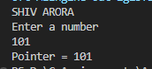

P2. Write a program in C to add two numbers using pointers. #include <stdio.h>

void main() {

printf("SUHANI NAGAR\n"); int n1, n2, sum;

int *ptr1, *ptr2, *ptr_sum; printf("Enter two numbers: "); scanf("%d %d", &n1, &n2);

ptr1 = &n1, ptr2 = &n2, ptr_sum = &sum;

*ptr_sum = *ptr1 + *ptr2; printf("Sum = %d\n", *ptr_sum);

}

OUTPUT:

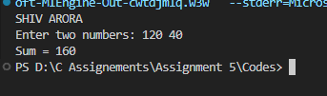

P3. Write a program in C to find the maximum number between two numbers using a pointer. #include <stdio.h>

void main() {

printf("SUHANI NAGAR\n"); int n1, n2;

int *ptr1, *ptr2;

printf("Enter two numbers: "); scanf("%d %d", &n1, &n2); ptr1 = &n1;

ptr2 = &n2;

if (*ptr1 > *ptr2) printf("Maximum: %d\n", *ptr1); else printf("Maximum: %d\n", *ptr2);

} OUTPUT:

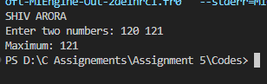

P4. Write a program in C to store n elements in an array and print the elements using a pointer. #include <stdio.h>

void main() { printf("SUHANI NAGAR\n"); int size;

printf("Enter the number of elements: "); scanf("%d", &size);

int arr[size]; int *ptr = arr;

printf("Enter elements:\n"); for (int i = 0; i < size; i++) { scanf("%d", ptr + i);

}

printf("Elements in array are:\n"); for (int i = 0; i < size; i++) {

printf("%d ", *(ptr + i));

}

} OUTPUT:

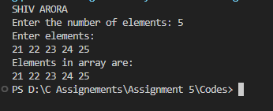

P5. Create a structure called "Student" with members name, age, and total marks. Write a C program to input data for two students, display their information, and find the average of total marks.

#include <stdio.h> typedef struct Student {

char name[50]; int age;

float total_marks;

}Student; void main() {

printf("SUHANI NAGAR\n"); Student s1, s2;

printf("Enter details for student 1:\n"); printf("Name, Age, Total Marks \n");

scanf("%s %d %f", s1.name, &s1.age, &s1.total_marks);

printf("Enter details for student 2:\n"); printf("Name, Age, Total Marks \n");

scanf("%s %d %f", s2.name, &s2.age, &s2.total_marks); printf("\nDetails of Students:\n");

printf("Student 1: %s, Age: %d, Marks: %.2f\n", s1.name, s1.age, s1.total_marks); printf("Student 2: %s, Age: %d, Marks: %.2f\n", s2.name, s2.age, s2.total_marks); float average = (s1.total_marks + s2.total_marks) / 2;

printf("Average Marks: %.2f\n", average);

} OUTPUT:

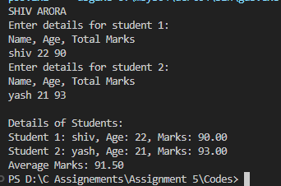

P6. Define a structure named Time with members hours, minutes, and seconds. Write a C program to input two times, add them, and display the result in proper time format.

#include <stdio.h> typedef struct Time {

int hours; int minutes; int seconds;

} Time;

Time addTimes(Time t1, Time t2) { Time result;

result.seconds = t1.seconds + t2.seconds;

result.minutes = t1.minutes + t2.minutes + result.seconds / 60; result.seconds %= 60;

result.hours = t1.hours + t2.hours + result.minutes / 60; result.minutes %= 60;

result.hours %= 24; return result;

}

void main() {

printf("SUHANI NAGAR\n"); Time t1, t2, result;

printf("Enter time 1 (HH MM SS): ");

scanf("%d %d %d", &t1.hours, &t1.minutes, &t1.seconds); printf("Enter time 2 (HH MM SS): ");

scanf("%d %d %d", &t2.hours, &t2.minutes, &t2.seconds); result = addTimes(t1, t2);

printf("Sum of times: %d:%d:%d\n", result.hours, result.minutes, result.seconds);

} OUTPUT:

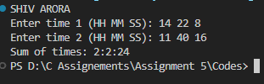

P7. Define a structure named Circle to represent a circle with a radius. Write a C program to calculate the area and perimeter of two circles and display the results.

#include <stdio.h> #include <math.h> #define M_PI 3.14 typedef struct Circle {

float radius;

}Circle;

void calculate(Circle c, float *area, float *perimeter) {

*area = M_PI * c.radius * c.radius;

*perimeter = 2 * M_PI * c.radius;

}

void main() {

printf("SUHANI NAGAR\n"); Circle c1, c2;

float area1, perimeter1, area2, perimeter2; printf("Enter radius of circle 1: "); scanf("%f", &c1.radius);

printf("Enter radius of circle 2: "); scanf("%f", &c2.radius); calculate(c1, &area1, &perimeter1); calculate(c2, &area2, &perimeter2);

printf("Circle 1: Area = %.2f, Perimeter = %.2f\n", area1, perimeter1); printf("Circle 2: Area = %.2f, Perimeter = %.2f\n", area2, perimeter2);

} OUTPUT:

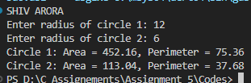

P8. Write a program in C to print all perfect numbers in a given range using the function. #include <stdio.h>

#include<stdbool.h> bool isPerfect(int n) {

int sum = 0;

for (int i = 1; i <= n / 2; i++) { if (n % i == 0) {

sum += i;

}

}

return sum == n;

}

void findPerfectNumbers(int low, int high) {

printf("The perfect numbers between %d to %d are:\n", low, high); for (int i = low; i <= high; i++) {

if (isPerfect(i)) { printf("%d ", i);

}

}

printf("\n");

}

void main() {

printf("SUHANI NAGAR\n"); int low, high;

printf("Input lowest limit: "); scanf("%d", &low); printf("Input highest limit: "); scanf("%d", &high); findPerfectNumbers(low, high);

} OUTPUT:

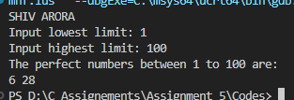

P9. Write a program in C to count the digits of a given number using recursion. #include <stdio.h>

int countDigits(int n) { if (n == 0) {

return 0;

}

return 1 + countDigits(n / 10);

}

void main() {

printf("SUHANI NAGAR\n"); int n;

printf("Enter a number: "); scanf("%d", &n);

printf("Number of digits: %d\n", countDigits(n));

} OUTPUT:

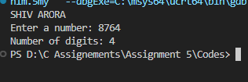

P10. Write a program in C to convert a decimal number to binary using recursion. #include <stdio.h>

void decimalToBinary(int num) { if (num == 0) {

return;

}

decimalToBinary(num / 2); printf("%d", num % 2);

}

void main() {

printf("SUHANI NAGAR\n"); int num;

printf("Input any number: "); scanf("%d", &num); printf("Binary = ");

if (num == 0) { printf("0");

} else {

decimalToBinary(num);

}

printf("\n");

} OUTPUT:

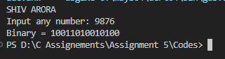

P11. Create a structure named "Employee" to store employee details such as employee ID, name, and salary. Write a program to input data for three employees, find the highest salary employee, and display their information.

#include <stdio.h> #include <string.h> typedef struct Employee {

int id;

char name[50]; float salary;

}Employee; void main() {

printf("SUHANI NAGAR\n"); int size;

printf("Enter the number of employes \n"); scanf("%d", &size);

Employee emp[size]; int highestIndex = 0;

printf("Enter details for employees\n"); for (int i = 0; i < size; i++) {

printf("ID, name , salary: \n");

scanf("%d %s %f", &emp[i].id, emp[i].name, &emp[i].salary); if (emp[i].salary > emp[highestIndex].salary) highestIndex = i;

}

printf("\nEmployee with the highest salary:\n"); printf("ID: %d\n", emp[highestIndex].id);

printf("Name: %s\n", emp[highestIndex].name); printf("Salary: %.2f\n", emp[highestIndex].salary);

} OUTPUT:

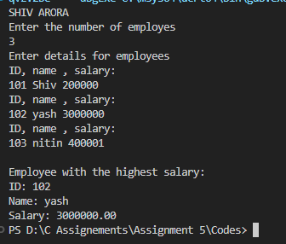

P12. Write a program in C to find the largest element using Dynamic Memory Allocation. #include <stdio.h>

#include <stdlib.h> void main() {

printf("SUHANI NAGAR\n"); int size;

int *arr, largest;

printf("Enter the number of elements: "); scanf("%d", &size);

arr = (int *)malloc(size * sizeof(int)); printf("Enter elements:\n");

for (int i = 0; i < size; i++) { scanf("%d", &arr[i]);

}

largest = arr[0];

for (int i = 1; i < size; i++) { if (arr[i] > largest) {

largest = arr[i];

}

}

} OUTPUT:

printf("Largest = %d\n", largest); free(arr);

